President’s Letter for September 17, 2022

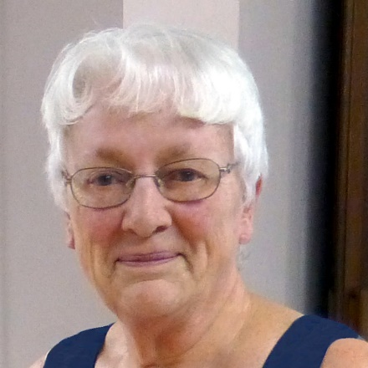
This month’s President’s Letter is a most difficult one to write. Our beloved web designer, Judy Loose, passed away and we are all deeply grieved.

Judy was capable of gracefully juggling many projects simultaneously; she will be greatly missed. Be assured that Gulf Coast Writers Association will continue being the leading writing group in Southwest Florida. We have been blessed with a new member, Dr. Kesha Dreher, who is also an IT expert. At her first meeting, she quickly agreed to take over the website while vacationing in Maui and is in the process of putting everything together.

We ask for your patience and support during this transition. Our September program will go forward as planned and we expect that our guest speaker, Lucy Tobias, will not disappoint you.

Lucy Tobias will give a PowerPoint presentation of undiscovered Florida (translation — drop dead beautiful photos); she presents ways to combine photos, video, and audio to your stories. How much of Florida still remains a mystery to some of us? Lucy will bring magic and excitement to the podium.

One additional benefit you will obtain from this presentation is a short exercise on writing the “hook” — the all-important first sentence of any book! In journalism, it is called a “grabber.” This was the most valuable tool I learned as a writer.

Lucy Tobias is an award-winning author and blogger who looks at life and finds humor, beauty, and reasons for hope.

Her book, The Zen of Florida Gardening, won first place in outdoor books in the excellence in crafts awards (2021) for the Florida Outdoor Writers Association.

Tobias’ Wednesday Notes, published in 2022, is her newest book.. A five-star review on Amazon said in part: “A weekly blog that started as a pandemic panacea and became a phenomenon - combination journal, travel log and memoir that looks at the profoundness of everyday life and finds humor, tragedy and reasons for hope. A good read for the jaded of heart who might have forgotten that miracles happen every day.”
“Wednesday Notes invites the reader to reflect on the moments of goodness and grace that happen in life. The author’s insights and wonderful sense of humor shine through. Written during the pandemic, there is a tenderness and authenticity that shines through. Lucy Tobias is a faithful, thoughtful, fun-loving friend in the journey of life.”

If you are attending via zoom, please sign up for the program. Honestly, we believe you will enjoy the program more if you are physically present. The opportunity to meet and enjoy the company of other members is extremely uplifting and encouraging during these discouraging times.

Location: Map
Word of Life Church
6111 South Pointe Blvd.
Fort Myers, FL 33919

Note: Google maps or your GPS may direct you to the back of the building. The entrance to the parking lot is on South Point Blvd. between Quigley Eye Specialists and Buckets Restaurant.
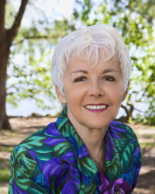
Irene Smith, President

