NEWS SPORTS OPINION OBITUARIES CLASSIFIEDS HURRICANE GUIDE

Home / News / News from around the region / Gulf Coast Writers Association holding writing contest

Gulf Coast Writers Association

holding writing contest

By Staff | Mar 30, 2023

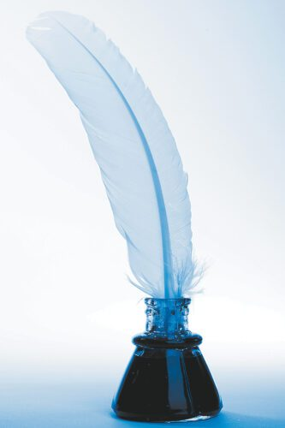

A writing contest open to the general public including adults and youth has been announced by the Gulf Coast Writers Association, with winners to be named in July.
Submissions are being accepted in the Adult section from persons 18 years old and older in four categories: Fiction, Nonfiction, Poetry and Children’s Stories. In the Youth section, submissions are being accepted from persons 11 to 17 years old in three categories: Fiction, Nonfiction and Poetry.
The deadline for entries, to be submitted online, for both sections is May 31, at 11:59 p.m.
“This annual contest advances our goal of encouraging writing and recognizing outstanding writers,” said Irene Smith, president of the Fort Myers-based nonprofit in making the announcement.
Winners will be announced at the GCWA monthly meeting on July 15.
The list of winners will be posted on gulfwriters.org.
All monthly meetings, currently held at Word of Life Church, 6111 South Pointe Blvd. in Fort Myers at 10 a.m. on the third Saturday, are open to the public.

Source: https://www.lehighacrescitizen.com/2023/03/30/gulf-coast-writers-association-holding-writing-contest/

