Arts & Culture

GCWA writing contest has multiple

categories for adults, adolescents
WGCU | By WGCU Staff
Published March 31, 2023 at 11:03 AM EDT

writing
The Gulf Coast Writers Association is offering a writing contest open to the general public including adults and youth with winners to be named in July.
Submissions are being accepted in the adult section from those 18 and older in four categories: Fiction, Nonfiction, Poetry, and Children’s Stories.
In the Youth section, submissions are being accepted from those 11 to 17 years old in three categories: Fiction, Nonfiction and Poetry. The deadline for entries, to be submitted online, for both sections is May 31 at 11:59 p.m.
“This annual contest advances our goal of encouraging writing and recognizing outstanding writers,” said Irene Smith, president of the Fort Myers-based nonprofit in making the announcement.
GCWA’s contest last year received recognition from Reedsy, a marketplace of freelance publishing professionals, as among the Best Writing Contests. Winners will be announced at the GCWA monthly meeting on July 15. The list of winners will be posted on the organization’s website (https://gulfwriters.org). All monthly meetings, currently held at Word of Life Church, 6111 South Pointe Blvd. In Fort Myers at 10 a.m. On the third Saturday, are open to the public.
Judges for the contest are members of GWCA as well as experienced writers from the community. Judging is done on a blind basis and members who submit entries will not judge their own entries. Adult Section Sponsors of the Adult section of the contest include Ft. Myers Magazine and writers’ guides Firstwriter.com and Duotrope®.
All winning entries in each category will be published on the GCWA website. There is no limit to number of submissions but entrants may win only one prize. GWCA members may participate in the contest in addition to the general public.
The entry fee for the adult section is: Non-Members: $20/1st submission, $10/each additional entry. Members: $10/1st submission, $5/each additional entry
Youth section winning entries are free and limited overall to three per person. Only one prize to an entrant will be awarded and will be published on the GCWA website.
Additional information for entrants is also available by emailing specialprojects@gulfwriters.org . Only entries submitted online will be considered.
The GCWA, founded in 1995 and incorporated in 2004, provides a forum for fellowship, education, and information for writers. GCWA’s well-regarded annual writing contest draws a wide-range of authors. Based in Fort Myers, the organization attracts members from throughout Southwest Florida from Marco Island to Tampa.
WGCU is your trusted source for news and information in Southwest Florida. We are a nonprofit public service, and your support is more critical than ever. Keep public media strong and donate now. Thank you.

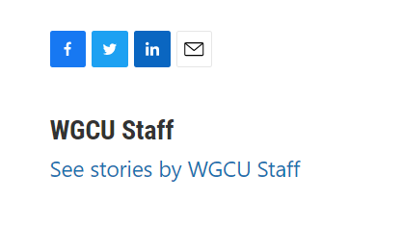

Source: https://news.wgcu.org/section/artsandculture/2023-03-31/gcwa-writing-contest-has-multiple-categories-for-adults-adolescents

